Software Requirement Specification Document

For

PLANT DISEASE DETECTION

Table of Contents
Page Numbers
- Introduction
  - Purpose 4
  - Intended Customers/Users 4
  - Product Scope 4-5
  - Outline of the document 5
- Overall Description
  - Product Perspective 5-6
  - Product Functions 6
  - User Classes 6
  - Design and Implementation Constraints 7
- Diagrams
  - UML Diagrams8-25
  - ER Diagrams 25
  - DFD Diagrams25-26
- External Interface Requirements/Screenshots
  - User Interfaces 26
  - Hardware Interfaces26-27
  - Software Interfaces27
  - Communication Interfaces28
- Other Non-Functional Requirements
  - Performance Requirements28
  - Safety Requirements29
  - Security Requirements29
  - Software Quality Attributes 29
  - Business Policies/Rules (if any) 29
- Testing
  - White-Box Testing30-40
  - Block-Box Testing40-43
- Conclusion 43-44
- References 44
- Acknowledgements44
- Component Diagram46
- Deployment Diagram46-47
- Product Metrics47-52
- COCOMO Model 54-57

1. Introduction

1.1 Purpose
- The purpose of this software is to detect diseases in plants using image processing and machine learning techniques.
- The system helps farmers, students, and agricultural professionals identify plant diseases quickly and accurately.
- It reduces manual inspection effort and minimizes crop loss caused by late disease detection.
- The software provides disease name and possible precautions or treatment suggestions.
- This SRS document describes:
  - Overall system functionality
  - User requirements
  - System constraints
  - User classes and features
  - Operating environment and limitations

1.2 Intended Customers / Users
- Farmers
  - Upload plant leaf images to detect diseases.
  - Receive disease information and basic treatment suggestions.
- Agriculture Students
  - Use the system for learning and project demonstrations.
  - Analyze plant disease patterns.
- Researchers
  - Test and improve disease detection models.
  - Collect plant image datasets.
- Administrators
  - Maintain the system.
  - Manage dataset updates and model improvements.

1.3 Product Scope
- The system allows users to upload images of plant leaves.
- The system processes the image using a trained machine learning model.
- It identifies the plant disease or confirms if the plant is healthy.
- It displays the disease name with basic precautions.
- The system stores uploaded images and results for analysis.
- The application can run on a computer or web browser.

1.4 Outline of the Document
- Chapter 1 – Introduction
  - Describes purpose, users, scope, and document overview.
- Chapter 2 – Overall Description
  - Explains system environment, features, users, and constraints.
- Future Chapters
  - Functional requirements
  - Non-functional requirements
  - System design
  - Testing and validation

2. Overall Description

2.1 Product Perspective
- The Plant Disease Detection System is a standalone software application.
- It can also be integrated with a larger agricultural monitoring system in future.
- The system interacts with:
  - Image input devices (camera / mobile images).
  - Local or cloud database for storing images and results.
  - Machine learning model for disease classification.
- The system may interact with internet services for model updates or dataset access.
- Example:
  - The system processes leaf images and connects with a trained ML model to identify diseases.

2.2 Product Functions
- Upload plant leaf image.
- Pre-process the image (resize, noise removal, normalization).
- Analyze image using trained machine learning model.
- Detect disease or healthy condition.
- Display disease name and confidence level.
- Provide basic treatment or precaution suggestions.
- Store detection history.
- Allow administrator to update dataset and model.

2.3 User Classes
- Farmer / User
  - Upload images.
  - View disease results.
  - View precautions.
- Student / Researcher
  - Test different images.
  - Analyze accuracy and results.
  - Use for academic purposes.
- Administrator
  - Manage database.
  - Update machine learning model.
  - Monitor system performance.
  - Generate reports.

2.4 Design and Implementation Constraints
- Hardware Limits
  - Requires camera or image upload device.
  - Minimum RAM and processor needed for image processing.
- Software Requirements
  - Python environment.
  - Libraries such as OpenCV, TensorFlow / PyTorch.
  - Operating system compatibility (Windows / Linux).
- Regulatory Rules
  - Data privacy for stored images.
- Network Dependency
  - Internet required for cloud model updates (optional).
- Database Size
  - Limited storage based on system capacity.
- Browser Issues
  - Performance may vary across browsers.
- Security Constraints
  - User data protection.
  - Secure access for admin features.

3. Diagrams
This chapter presents the graphical representation of the Plant Disease Detection System.
The diagrams help to understand the structure, functionality, and data flow of the system clearly.
It includes UML diagrams, ER diagrams, and Data Flow Diagrams (DFD).

3.1 UML Diagrams
a) Use-Case Diagram
The Use-Case Diagram represents the interaction between users and the system.
It shows what actions different users can perform in the Plant Disease Detection System.
The main actors are:
- User (Farmer / Student)
- Administrator
The major functionalities include:
- User registration and login
- Uploading plant leaf images
- Viewing disease detection results
- Viewing precaution and treatment suggestions
- Managing datasets and updating machine learning models by admin
This diagram helps in identifying system functionalities from the user’s point of view.

Use-Case Diagram

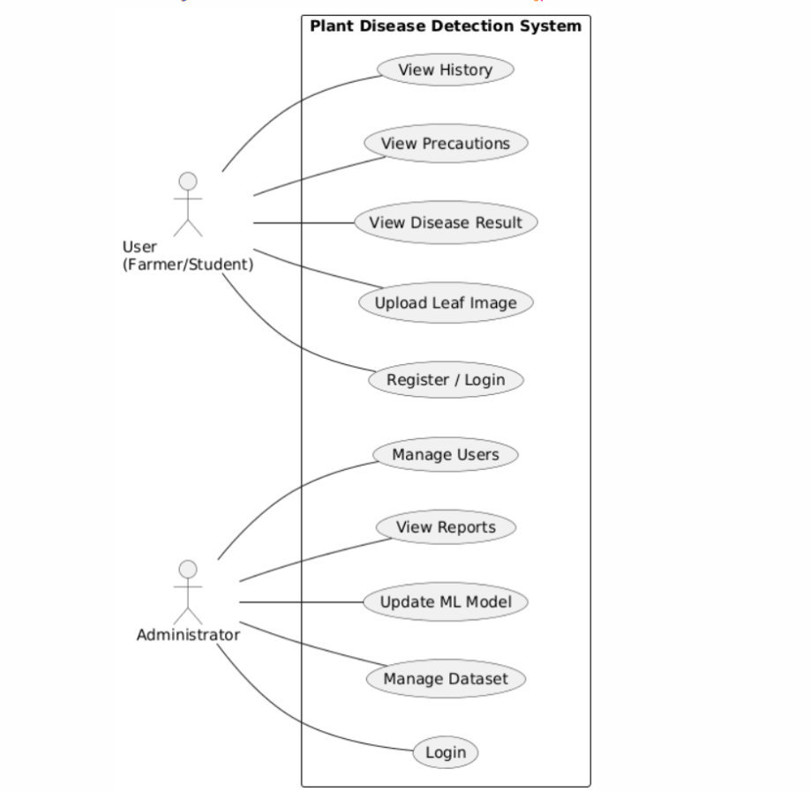

Module-wise Use-Case Description
To better understand the system, the use-case diagram is divided into the following modules:

Module 1: User Management Module
Description:
This module handles user registration, login, and profile management. It ensures secure access to the system and differentiates between normal users and administrators.
Primary Actors:
- User
- Administrator
Functions:
- Register
- Login
- Logout
- Manage users (Admin)
Use-Case Diagram

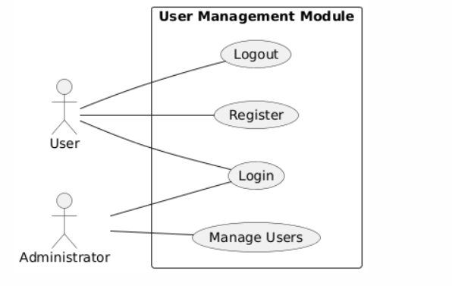

Module 2: Image Upload and Pre-processing Module
Description:
This module allows users to upload plant leaf images. The system verifies image format and performs basic pre-processing before disease detection.
Primary Actor:
- User
Functions:
- Select image
- Upload image
- Validate image

Use-Case Diagram
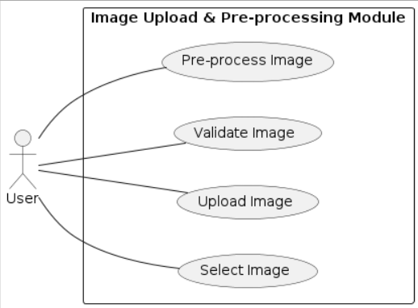

Module 3: Disease Detection Module
Description:
This module analyzes the uploaded image using a trained machine learning model and predicts whether the plant is healthy or infected.
Primary Actor:
- System
Secondary Actor:
- User
Functions:
- Load ML model
- Analyze image
- Predict disease
- Generate confidence score

Use-Case Diagram

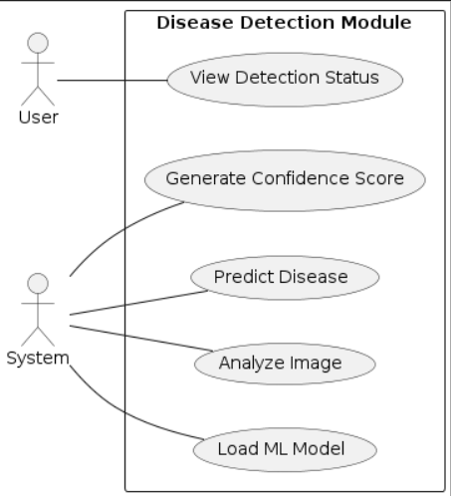

Module 4: Result and Recommendation Module
Description:
This module displays the detected disease name and provides precaution or treatment suggestions to the user.
Primary Actor:
- User
Functions:
- View disease result
- View confidence level
- View precautions

Use-Case Diagram

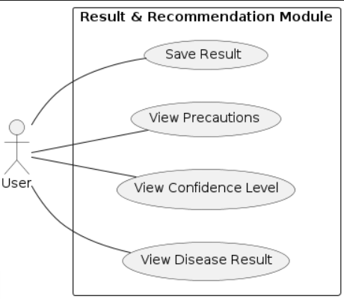
Module 5: Admin and Dataset Management Module
Description:
This module is used by the administrator to manage datasets and update the machine learning
Model to improve accuracy
Primary Actor:
- Administrator
Functions:
- Upload dataset
- Update ML model
- Monitor system performance
- Generate reports

Use-Case Diagram
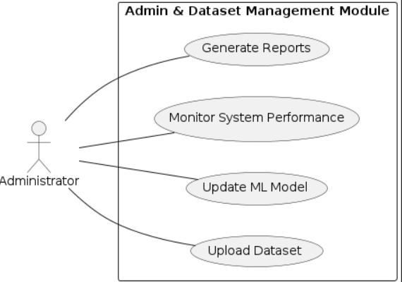
b) Class Diagram
The Class Diagram represents the static structure of the system.
It shows the classes, their attributes, methods, and relationships between different components of the Plant Disease Detection System.
Each module has its own class diagram to clearly represent internal working.

Module 1: User Management Module — Class Diagram
Description:
This module manages user registration, login, and access control. It differentiates between normal users and administrators.
Main Classes:
- User
- Admin
Responsibilities:
- User handles registration and login.
- Admin manages system users.

Class Diagram

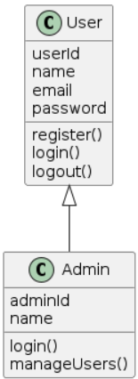

Module 2: Image Upload & Pre-processing Module — Class Diagram
Description:
This module handles image uploading and prepares the image for disease detection by performing validation and pre-processing.
Main Classes:
- User
- Image
- ImageValidator
- PreProcessor

Class Diagram

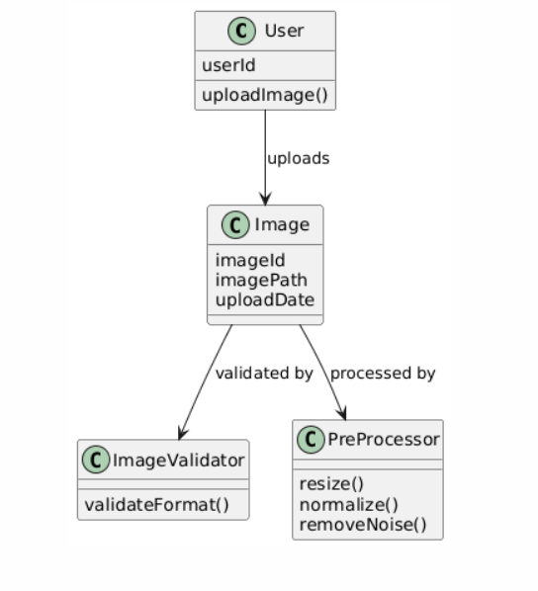
Module 3: Disease Detection (ML) Module — Class Diagram
Description:
This module performs disease prediction using machine learning algorithms.
Main Classes:
- MLModel
- FeatureExtractor
- DiseaseResult

Class Diagram
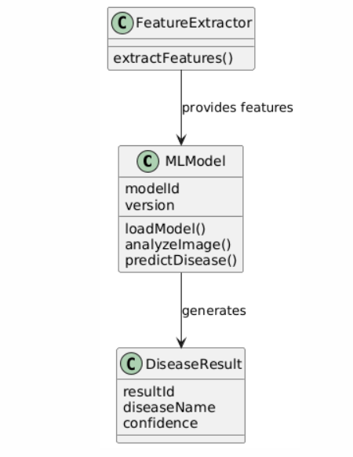
Module 4: Result & Recommendation Module — Class Diagram
Description:
This module displays disease results and provides treatment or precaution suggestions to users.
Main Classes:
- DiseaseResult
- Recommendation
- History

Class Diagram

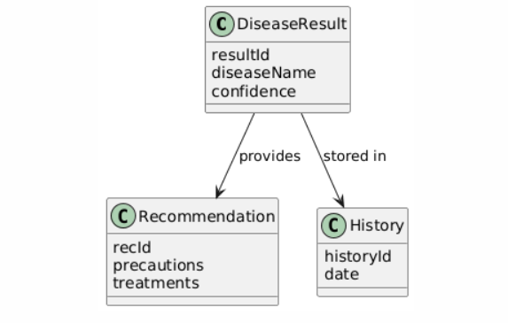
Module 5: Admin & Dataset Management Module — Class Diagram
Description:
This module allows administrator to update datasets and retrain machine learning models.
Main Classes:
- Admin
- Dataset
- Report

Class Diagram
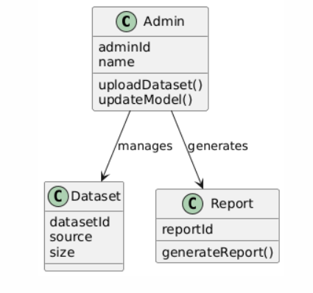

State Chart Diagram (for Image Upload and Disease Detection Module)
The State Chart Diagram represents different states involved in the Image Upload and Disease Detection Module and the transitions between them.
This diagram explains how the system changes its state from image uploading to disease detection and result display.
States included:
- Waiting for Image
- Image Uploaded
- Image Pre-processed
- Disease Detection
- Result Displayed
- Completed
The system starts by waiting for the user to upload an image, then processes the image, detects disease using machine learning model, displays the result, and finally completes the process.

Diagram:
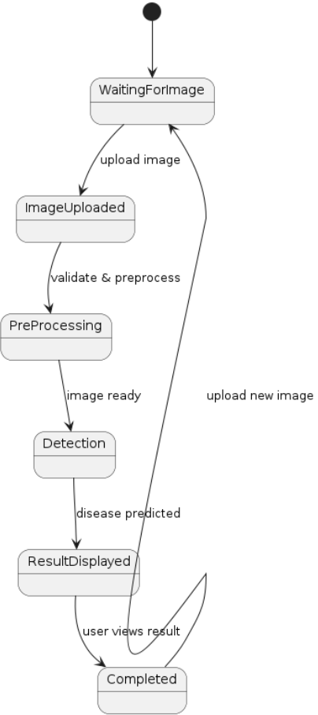
Activity Diagram (for Image Upload and Disease Detection Module)
The Activity Diagram shows the sequence of activities performed in the Image Upload and Disease
Detection model.
It represents how the user and system interact step-by-step to detect plant disease from leaf image.
Activities included:
- User selects image
- Uploads image
- System validates image
- Pre-processes image
- Applies ML model
- Displays disease result and precautions

Diagram:

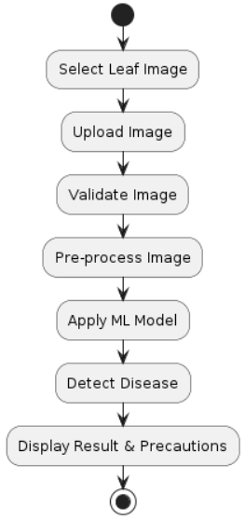

Activity Diagram (for Admin and Dataset Management Module)
The Activity Diagram represents the sequence of activities performed by the administrator while managing datasets and updating the machine learning model.
It shows how the admin uploads new datasets, updates the model, and generates reports.
Activities included:
- Admin logs in
- Uploads dataset
- System validates dataset
- Updates ML model
- Tests model performance
- Generates system report

Diagram:

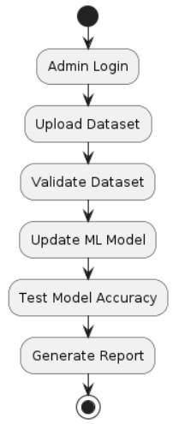
Sequence and Collaboration Diagrams
Sequence and Collaboration diagrams show how different classes interact with each other to perform the functions of the Plant Disease Detection System.
Sequence diagram shows interaction based on time order, while Collaboration diagram shows communication between objects.

Module 1 – User Management
Sequence Diagram
This diagram shows how the user logs into the system and gets access.

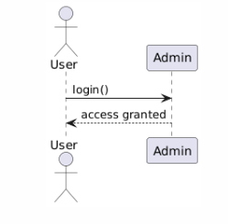

Collaboration Diagram
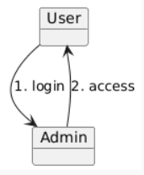
Module 2 – Image Upload & Pre-processing
Sequence Diagram
This diagram shows how the image is uploaded and processed

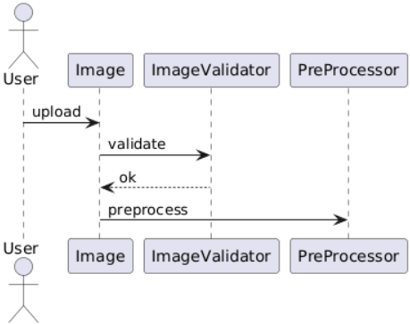

Collaboration Diagram

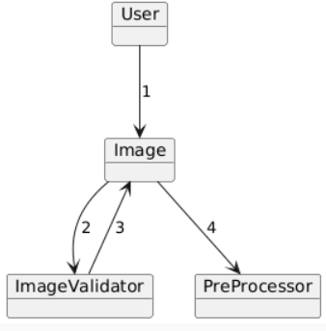

Module 3 – Disease Detection
Sequence Diagram
This diagram shows how the system detects disease using the ML model.
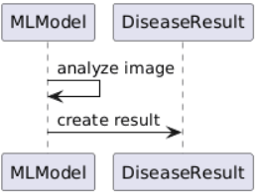

Collaboration Diagram
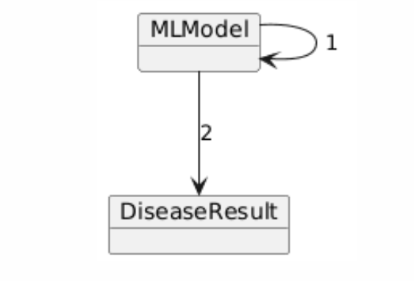
Module 4 – Result & Recommendation
Sequence Diagram
This diagram shows how the result and precautions are displayed to the user.
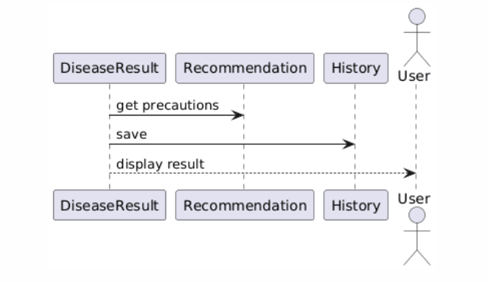

Collaboration Diagram

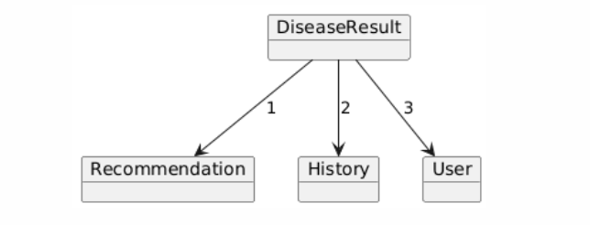

Module 5 – Admin & Dataset Management
Sequence Diagram
This diagram shows how admin updates dataset and generates report.
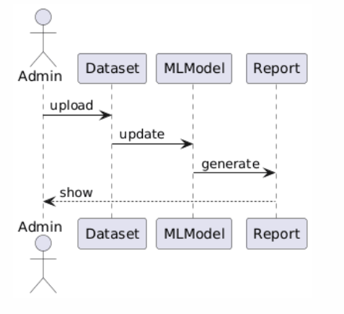

Collaboration Diagram
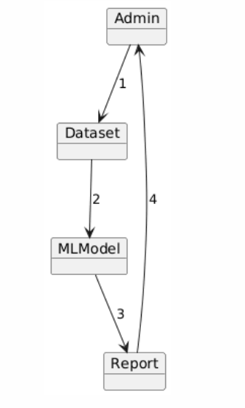
3.2 ER DIAGRAM:

ER Diagram (Entity Relationship Diagram) represents the structure of the database by showing
entities, their attributes, and the relationships between them. It helps in designing the database
clearly before implementing it in the system.

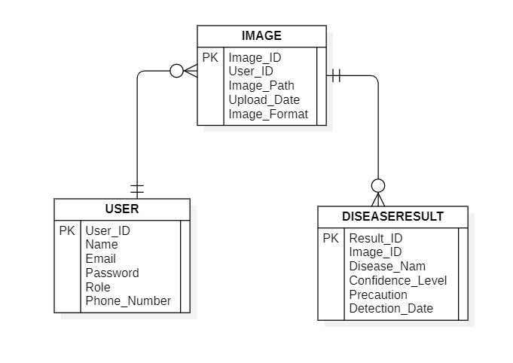
3.3 DFD Diagrams:

DFD (Data Flow Diagram) shows how data moves through the system between users, processes,
and data stores. It helps in understanding the flow of information and the overall working of the
system.
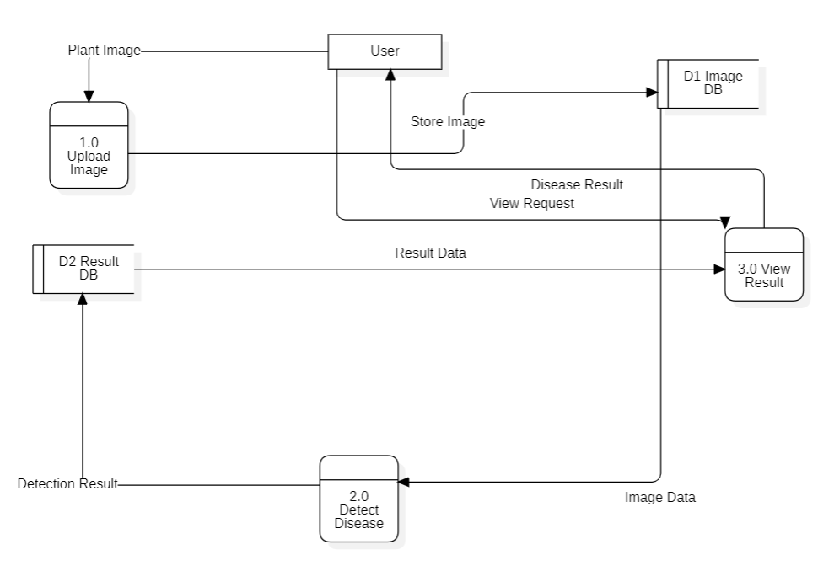
CHAPTER 4
EXTERNAL INTERFACE REQUIREMENTS

This chapter discusses how the system will interact with the outside world in terms of users.

4.1 User Interfaces

The system has a user-friendly interface for different users of the system.

User Interface

- The user interface will enable the user to:
    - Register and log in to the system
    - Upload images of plant leaves
    - View the detection of plant diseases
    - View the confidence level of the prediction

- The user interface will provide the following:
    - Image upload screen
    - Result display screen
    - Image upload history

- The user interface will be:
  - Easy to use
  - Simple and clear
  - Accessible through a browser on a desktop or laptop

Administrator Interface

- The administrator interface will enable the administrator to:
  - Manage the system users
  - View uploaded images
  - View system usage

- The administrator interface will provide the following:
  - Dashboard for managing users and images
  - Option to view detection results

4.2 Hardware Interfaces
This section describes the hardware required for using the system.
- The system needs:
  - A computer or laptop
  - A camera or mobile camera to capture plant leaf images
- Hardware used in the project:
  - Camera: To take pictures of plant leaves
  - Storage device: To store images and results
- The system works on normal computer hardware and does not require any special devices.
4.3 Software Interfaces
This section explains the software used in the system.
- The system works with:
  - Operating System like Windows or Linux
  - Database such as MySQL or MongoDB
  - Web browser like Chrome or Edge
- The software components include:
  - A backend server to process images
  - A machine learning model to detect plant diseases
  - A database to store user details, images, and results
- The system may use different libraries and tools for image processing and disease detection
4.4 Communication Interfaces
This section explains how data is transferred in the system.
- The system uses:
  - Internet connection
  - HTTP or HTTPS protocol for communication
- The user uploads the image through the internet and the server sends back the result.
- The system can work on:
  - LAN
  - Wi-Fi
  - Internet connection
- Data like images and results are exchanged between the user and the server.
Chapter 5: Other Non-Functional Requirements

5.1 Performance Requirements
- The system should:
  - Respond quickly to user requests
  - Process images in less time
  - Support multiple users at the same time
- The system should display the disease result within a few seconds after uploading the image.

5.2 Safety Requirements
Safety is about protecting data and avoiding system failure.
- The system should:
  - Store backup of important data
  - Prevent data loss
  - Handle errors properly
- If any problem occurs, the system should show proper error messages and recover safely.
5.3 Security Requirements
- The system should:
  - Provide login and authentication for users
  - Allow only registered users to use the system
- Security features include:
  - User login system
  - Secure storage of passwords
- Only authorized users should be able to access the system.

5.4 Software Quality Attributes
- Reliability: The system should work properly without frequent errors.
- Usability: The system should be easy to use for any user.
- Scalability: The system should support more users in the future.
- Maintainability: The system should be easy to update and modify.
The system is designed to be user-friendly and easy to maintain.

5.5 Business Policies / Rules
- This project is developed mainly for academic purpose.
- There are no special business rules applied to this system.

Chapter 6.1 : White box testing
White box testing is a testing technique, that examines the program structure and
derives test data from the program logic/code.

Sample code1:
def login_system(username, password):

if username == "":
print("Username cannot be empty")
return

if password == "":
print("Password cannot be empty")
return

if len(password) < 4:
print("Password too short")
return

if username == "admin" and password == "1234":
print("Login Successful")

elif username == "admin":
print("Wrong password")

else:
print("User not found")

print("Plant Disease Detection System Login")
u = input("Enter Username: ")
p = input("Enter Password: ")

login_system(u, p)

Sample code2:

def disease_result(confidence, disease_name):

if confidence <= 0:
print("Invalid confidence value")
return

if confidence < 50:
print("Image unclear. Upload again")

elif confidence >= 50 and confidence < 80:
print("Possible Disease Detected")
print("Disease:", disease_name)
print("Check precautions")

elif confidence >= 80:
print("Disease Confirmed")
print("Disease:", disease_name)
print("Apply treatment")

else:
print("Unknown condition")

confidence = float(input("Enter model confidence: "))
disease = input("Enter disease name: ")

disease_result(confidence, disease)

`1.Flow Graph Notation :

Sample code 1 : User Login Validation

def login_system(username, password):

if username == "":
print("Username cannot be empty")
return
if password == "":
print("Password cannot be empty")
return
if len(password) < 4:
print("Password too short")
return
if username == "admin" and password == "1234":
print("Login Successful")
elif username == "admin":
print("Wrong password")
else:
print("User not found")

print("Plant Disease Detection System Login")
u = input("Enter Username: ")
p = input("Enter Password: ")

login_system(u, p)
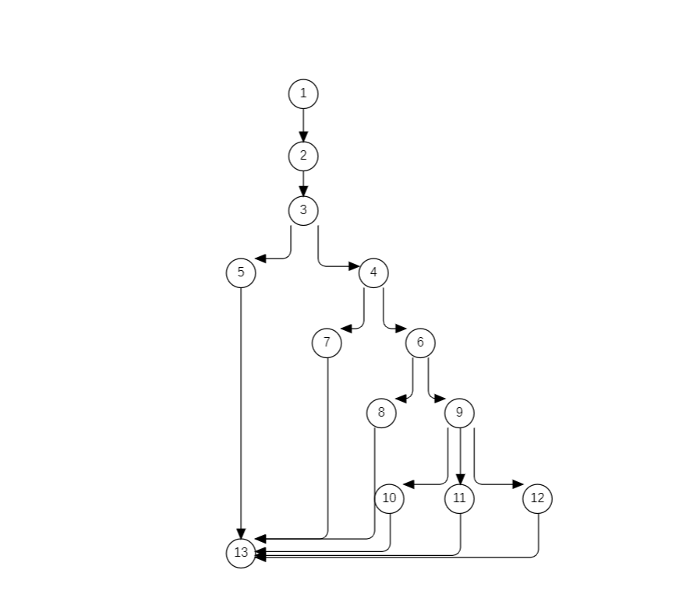
Sample code 2 : Disease Detection Result Check

def disease_result(confidence, disease_name):
if confidence <= 0:
print("Invalid confidence value")
return
if confidence < 50:
print("Image unclear. Upload again")
elif confidence >= 50 and confidence < 80:
print("Possible Disease Detected")
print("Disease:", disease_name)
print("Check precautions")
elif confidence >= 80:
print("Disease Confirmed")
print("Disease:", disease_name)
print("Apply treatment")
else:
print("Unknown condition")

confidence = float(input("Enter model confidence: "))
disease = input("Enter disease name: ")
disease_result(confidence, disease)

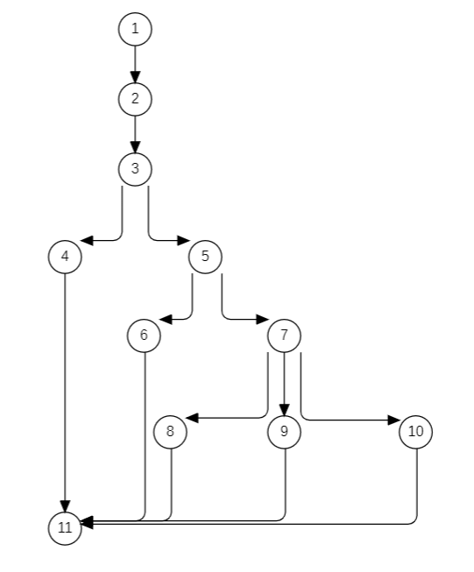

2.Cyclomatic Complexity

Sample code 1 :

Step 1: Count Decision Nodes
In the login code the conditions are:
- username == ""
- password == ""
- len(password) < 4
- username == "admin" and password == "1234"
- username == "admin"
Total decision nodes = 5

Cyclomatic Complexity Formula
V(G) = Decision Nodes + 1
V(G) = 5 + 1
V(G) = 6
Cyclomatic Complexity = 6
This means 6 independent paths exist.

Sample code 2:

Decision Conditions
- confidence <= 0
- confidence < 50
- confidence >= 50 and confidence < 80
- confidence >= 80
Total decision nodes = 4
Formula
V(G) = Decision Nodes + 1
V(G) = 4 + 1
V(G) = 5
Cyclomatic Complexity = 5

3.Independent Paths & Test Cases

Sample code 1 : Login System

Path No | Independent Path (Node Sequence) | Test Input (username, password) | Expected Output
P1 | 1,2,3,5,13 | ("", "1234") | Username cannot be empty
P2 | 1,2,3,4,7,13 | ("user", "") | Password cannot be empty
P3 | 1,2,3,4,6,8,13 | ("user", "12") | Password too short
P4 | 1,2,3,4,6,9,10,13 | ("admin", "1234") | Login Successful
P5 | 1,2,3,4,6,9,11,13 | ("admin", "9999") | Wrong password
P6 | 1,2,3,4,6,9,12,13 | ("abc", "1234") | User not found

Python unittest Code for Login System :

import unittest

def login_system(username, password):

if username == "":
return "Username cannot be empty"
if password == "":
return "Password cannot be empty"
if len(password) < 4:
return "Password too short"
if username == "admin" and password == "1234":
return "Login Successful"
elif username == "admin":
return "Wrong password"
else:
return "User not found"

class TestLogin(unittest.TestCase):

def test_username_empty(self):
self.assertEqual(login_system("", "1234"), "Username cannot be empty")
def test_password_empty(self):
self.assertEqual(login_system("user", ""), "Password cannot be empty")
def test_password_short(self):
self.assertEqual(login_system("user", "12"), "Password too short")

def test_login_success(self):
self.assertEqual(login_system("admin", "1234"), "Login Successful")
def test_wrong_password(self):
self.assertEqual(login_system("admin", "9999"), "Wrong password")
def test_user_not_found(self):
self.assertEqual(login_system("abc", "1234"), "User not found")

if __name__ == "__main__":
unittest.main()

OUTPUT :

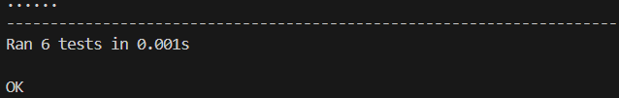

Sample code 2 : Disease Detection Result Check

Path No | Independent Path (Node Sequence) | Test Input (confidence) | Expected Output
P1 | 1,2,3,4,11 | -1 | Invalid confidence value
P2 | 1,2,3,5,6,11 | 30 | Image unclear
P3 | 1,2,3,5,7,8,11 | 60 | Possible disease detected
P4 | 1,2,3,5,7,9,11 | 90 | Disease confirmed
P5 | 1,2,3,5,7,10,11 | 100 | Treatment recommended

Python unittest Code for Disease Detection Result Check :

import unittest

def disease_result(confidence):

if confidence <= 0:
return "Invalid confidence value"
if confidence < 50:
return "Image unclear"
elif confidence < 80:
return "Possible disease detected"

elif confidence >= 80:
return "Disease confirmed"
else:
return "Treatment recommended"

class TestDisease(unittest.TestCase):

def test_invalid(self):
self.assertEqual(disease_result(-1), "Invalid confidence value")
def test_unclear(self):
self.assertEqual(disease_result(30), "Image unclear")
def test_possible(self):
self.assertEqual(disease_result(60), "Possible disease detected")
def test_confirmed(self):
self.assertEqual(disease_result(90), "Disease confirmed")
def test_high_value(self):
self.assertEqual(disease_result(100), "Disease confirmed")

if __name__ == "__main__":
unittest.main()

OUTPUT :

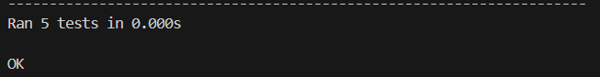

Chapter 6.2 : Black-box Testing
Step 1: Write Functional Requirements

For login_system:
- Username must not be empty
- Password must not be empty
- Password length must be at least 4 characters
- If username = "admin" and password = "1234" → Login Successful
- If username = "admin" but password is incorrect → Wrong Password
- If username does not exist → User Not Found

For disease_result:
- Confidence value must be greater than 0
- If confidence ≤ 0 → Invalid Confidence Value
- If confidence < 50 → Image Unclear
- If confidence between 50 and 79 → Possible Disease Detected
- If confidence ≥ 80 → Disease Confirmed

Step 2: Apply Black-Box Techniques
The following Black Box Testing techniques are applied:
- Equivalence Partitioning
- Boundary Value Analysis
1.Equivalence Partitioning
Divide inputs into logical groups.
Sample code 1 : Login System
Username
Class | Input | Valid/Invalid
EC1 | Empty Username | Invalid
EC2 | Valid Username | Valid
EC3 | Unknown Username | Invalid
Password
Class | Range | Result
EC4 | Empty Password | Password Error
EC5 | Length < 4 | Password Too Short
EC6 | Correct Password | Login Success
EC7 | Incorrect Password | Wrong Password
Test Cases
BB No | Test Input | Expected Output | Technique
BB1 | ("", "1234") | Username cannot be empty | EC1
BB2 | ("user", "") | Password cannot be empty | EC4
BB3 | ("user", "12") | Password too short | EC5
BB4 | ("admin", "1234") | Login Successful | EC6
BB5 | ("admin", "9999") | Wrong password | EC7
BB6 | ("abc", "1234") | User not found | EC3

Sample code 2 : Disease Detection Result Check
For Disease Result :
Class | Range | Result
EC1 | ≤ 0 | Invalid Confidence
EC2 | 1 – 49 | Image Unclear
EC3 | 50 – 79 | Possible Disease
EC4 | ≥ 80 | Disease Confirmed

Test Cases:
BB No | Test Input | Expected Output | Technique
BB7 | -1 | Invalid confidence value | EC1
BB8 | 30 | Image unclear | EC2
BB9 | 60 | Possible disease detected | EC3
BB10 | 90 | Disease confirmed | EC4

2.Boundary Value Analysis:
Boundary testing is the process of testing values near the limits where system
behavior changes.
Boundary values help detect errors that occur at extreme ends of input ranges.
Password Length Boundary (4 Characters)
BBNo | Test Input | Expected Output | Technique
BB11 | ("user","123") | Password too short | 4 − 1
BB12 | ("user","1234") | User not found | Boundary 4
BB13 | ("admin","12345") | Wrong password | 4 + 1

Confidence Boundary at 50
BB No | Test Input | Expected Output | Technique
BB14 | 49 | Image unclear | 50 − 1
BB15 | 50 | Possible disease detected | 50
BB16 | 51 | Possible disease detected | 50 + 1

Confidence Boundary at 80
BB No | Test Input | Expected Output | Technique
BB17 | 79 | Possible disease detected | 80 − 1
BB18 | 80 | Disease confirmed | 80
BB19 | 81 | Disease confirmed | 80 + 1

3. Black-box testing does NOT end with creating tables.
You now move to: Execute the Black-Box Test Cases Run your program manually or using simple function calls
Login System
Add statements like this to test the test cases:
print(login_system("", "1234"))
print(login_system("admin", "1234"))
print(login_system("user", "12"))
Output
Username cannot be empty
Login Successful
Password too short
Disease Result System
Add statements like this to test the test cases:
print(disease_result(-1))
print(disease_result(60))
print(disease_result(80))
Output
Invalid confidence value
Possible disease detected
Disease confirmed

Chapter 7 : CONCLUSION :
This Software Requirement Specification (SRS) document describes the requirements and functional details of the Plant Disease Detection System.
The main objective of this system is to help users detect plant diseases using leaf images and provide the appropriate results and precautions. The document explains the system requirements, system modules, diagrams, testing methods, and overall design of the system.
The SRS helps in clearly understanding how the system should work and what functionalities it should provide. It also helps developers and users understand the structure and behavior of the system.
Overall, this document provides a clear description of the system and acts as a guide for the development and implementation of the Plant Disease Detection System.

Chapter 8 : REFERENCES :
- IEEE Software Requirement Specification (SRS) Documentation Guidelines.
- Software Engineering Concepts and Principles – Standard Reference Materials.
- Python Programming Documentation – https://www.python.org
- Machine Learning and Image Processing Tutorials from Online Resources.
- Course Materials and Lecture Notes provided by the faculty.

Chapter 9 : ACKNOWLEDGMENT :
I would like to express my sincere thanks to my project guide and faculty members for their valuable guidance and support during the preparation of this Software Requirement Specification (SRS) document for the Plant Disease Detection System.
I also thank my college for providing the necessary resources and environment to complete this work successfully.

Design Phase

Chapter 10 : Component Diagram
The Component Diagram represents the high-level structure of the Plant Disease Detection System. It shows the different components of the system and how they interact with each other to perform disease detection.
The system consists of components such as the user interface, image upload module, image processing module, machine learning model, and database. These components work together to process the plant leaf image and generate the disease detection result.
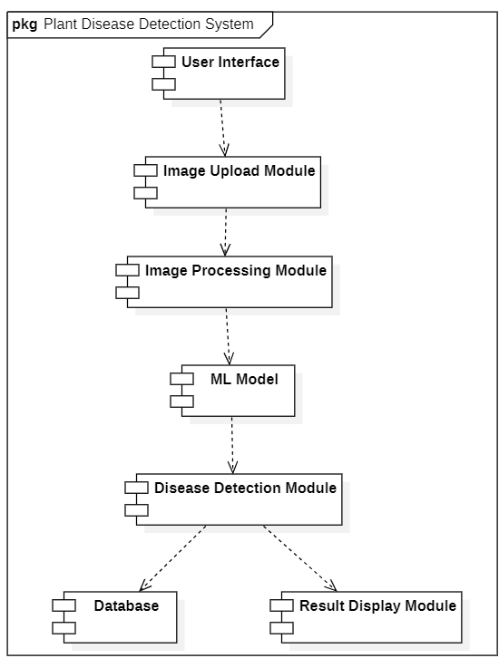

Chapter 11 : Deployment Diagram
The Deployment Diagram shows the physical architecture of the Plant Disease Detection System.It represents how the software components are deployed on hardware nodes.In this system, the user accesses the application through a device such as a mobile phone or computer. The request is processed by the application server, where the machine learning model analyzes the uploaded leaf image. The results are stored in the database and displayed to the user.

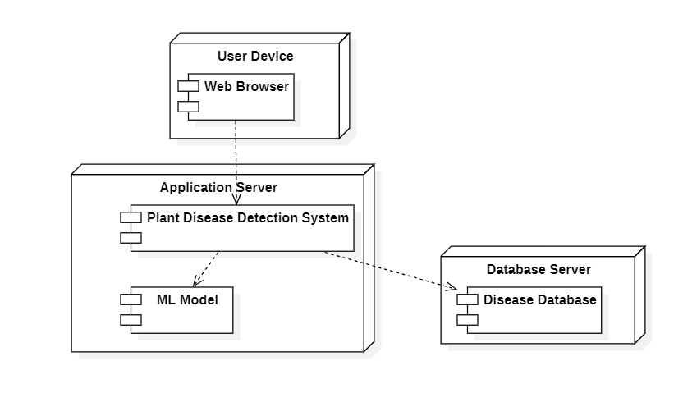

Chapter 12 : Product Metrics

Introduction to Function Point Analysis
Function Point Analysis (FPA) is a software measurement technique used to estimate the size and complexity of a software system.
It measures the functionality delivered to the user based on the system inputs, outputs, files, and interactions.
Function Point Analysis helps in:
- Estimating development effort
- Estimating project cost
- Predicting number of defects
- Estimating development time

To calculate the Function Points of a system, the following steps are performed:
- Identify the Information Domain Values such as External Inputs (EI), External Outputs (EO), External Inquiries (EQ), Internal Logical Files (ILF), and External Interface Files (EIF) and Calculate the Unadjusted Function Points (UFP) using standard weights for each component.
- Evaluate the 14 General System Characteristics to determine the system complexity.
- Calculate the Complexity Adjustment Factor (CAF).
- Finally, calculate the Function Points (FP) using UFP and CAF.
Calculation of Unadjusted Function Points (UFP) :

Standard weights are assigned to each component.
Component | Count | Weight | Total
External Inputs (EI) | 3 | 4 | 12
External Outputs (EO) | 2 | 5 | 10
External Inquiries (EQ) | 1 | 4 | 4
Internal Logical Files (ILF) | 3 | 10 | 30
External Interface Files (EIF) | 1 | 7 | 7

UFP Calculation
UFP = 12 + 10 + 4 + 30 + 7
UFP = 63

Value Adjustment Factors (VAF)
The system complexity is measured using 14 general system characteristics.
Each factor is rated from 0 to 5:
Rating | Meaning
0 | No Influence
1 | Incidental
2 | Moderate
3 | Average
4 | Significant
5 | Essential

Evaluation of the 14 System Characteristics
1. Reliable Backup and Recovery
The system stores uploaded images and results. Backup is required to avoid data loss.
Rating: 3 (Average)
2. Data Communication
The system communicates through the internet when users upload images and receive results.
Rating: 3 (Average)
3. Distributed Processing
The machine learning model may run on server or cloud environment.
Rating: 2 (Moderate)
4. Performance Requirements
The system must process images quickly and display results within a few seconds.
Rating: 3 (Average)
5. Operational Environment
The system runs on computers and browsers used by multiple users.
Rating: 2 (Moderate)
6. Online Data Entry
Users upload images and enter login details online.
Rating: 4 (Significant)

7. Multiple Screens for Input
Uploading images and entering data may require multiple steps.
Rating: 2 (Moderate)
8. Online File Updates
Uploaded images and results are stored in the database.
Rating: 3 (Average)
9. Complex Inputs/Outputs
Image processing and disease prediction require handling complex data.
Rating: 3 (Average)
10. Internal Processing Complexity
Machine learning algorithms perform complex image analysis.
Rating: 4 (Significant)
11. Code Reusability
Some modules like image processing and login system can be reused.
Rating: 2 (Moderate)
12. Installation and Setup
The system requires installation of Python libraries and ML models.
Rating: 2 (Moderate)
13. Multiple Organizations Use
The system can be used by farmers, students, and researchers.
Rating: 2 (Moderate)

14. Ease of Change and Use
The system is designed to be user friendly and easy to modify.
Rating: 3 (Average)

Calculation of ΣFi :
Sum of all ratings:
3 + 3 + 2 + 3 + 2 + 4 + 2 + 3 + 3 + 4 + 2 + 2 + 2 + 3
ΣFi = 38

Calculation of Complexity Adjustment Factor (CAF)
The CAF is calculated using the formula:
CAF = 0.65 + (0.01 * ΣFi )
CAF = 0.65 + (0.01 × 38)
CAF = 0.65 + 0.38
CAF = 1.03

Final Function Point Calculation :
The final Function Point value is calculated as:
$$FP=UFP×CAF$$
FP = 63 × 1.03
FP = 64.89 ≈ 65 Function Points
Example Calculations Using Function Points
Function Points can be used to estimate development effort, cost, time, and defects.
Example 1: Development Time Estimation
Assume:
1 Function Point = 8 hours of development
Total time:
65 × 8 = 520 hours
Example 2: Project Cost Estimation
Assume:
Developer cost = ₹800 per hour
Project cost:
520 × 800
Total cost = ₹4,16,000
Example 3: Team Size Estimation
If one developer works 8 hours per day:
520 / 8 = 65 days
If 3 developers work together:
65 / 3 ≈ 22 days
Example 4: Bug Prediction
Assume:
0.4 defects per Function Point
Expected defects:
65 × 0.4
≈ 26 defects
Example 5: Testing Effort
Testing effort is usually about 30% of development time.
Testing time:
520 × 0.30 = 156 hours

Empirical Estimation Models(COCOMO Model)

COCOMO Model for Plant Disease Detection System
Estimated Project Size
The estimated size of the Plant Disease Detection System is 12 KLOC (approximately 12,000 lines of source code).
This project is classified under the Organic mode in the COCOMO model because it is a small to medium-scale academic software project developed by a small team in a familiar environment.
This estimation is used to calculate:
- Development effort
- Development time
- Team size
i) Basic COCOMO Model
The Basic COCOMO model is used for quick software cost estimation.
Formula:
- Effort (E) = A × (KLOC)^B
- Time (T) = C × (Effort)^D
- Persons Required = Effort / Time
For Organic mode:
- A = 2.4
- B = 1.05
- C = 2.5
- D = 0.38
a) Effort Calculation
Effort = 2.4 × (12)^1.05
Effort = 2.4 × 13.59
Effort = 32.62 Person-Months
b) Development Time Calculation
Time = 2.5 × (32.62)^0.38
Time = 2.5 × 3.76
Time = 9.40 Months
c) Team Size Calculation
Persons Required = 32.62 / 9.40
Persons Required = 3.47 ≈ 4 Persons
Basic COCOMO Result:
- Estimated Effort = 32.62 Person-Months
- Estimated Development Time = 9.40 Months
- Average Team Size = 4 Persons

ii) Intermediate COCOMO Model
The Intermediate COCOMO model considers additional project factors called Cost Drivers.
Formula:
- Effort = A × (KLOC)^B × EAF
- Time = C × (Effort)^D
- Persons Required = Effort / Time
For Organic mode:
- A = 3.2
- B = 1.05
- C = 2.5
- D = 0.38

a) EAF Calculation
S.No | Cost Driver Factors | Rating | Multiplier
1 | Required software reliability | High | 1.15
2 | Database size | High | 1.08
3 | Product complexity | High | 1.15
4 | Run-time constraints | Nominal | 1.00
5 | Memory constraints | Nominal | 1.00
6 | Virtual machine volatility | Nominal | 1.00
7 | Turnaround time | Nominal | 1.00
8 | Analyst capability | High | 0.86
9 | Software engineering capability | High | 0.86
10 | Application experience | Nominal | 1.00
11 | Virtual machine experience | Nominal | 1.00
12 | Programming language experience | Nominal | 1.00
13 | Use of software tools | High | 0.91
14 | Use of software engineering methods | High | 0.91
15 | Required schedule | Nominal | 1.00

EAF:
EAF = 1.15 × 1.08 × 1.15 × 1.00 × 1.00 × 1.00 × 1.00 × 0.86 × 0.86 × 1.00 × 1.00 × 1.00 × 0.91 × 0.91 × 1.00
EAF = 0.96
b) Effort Calculation
Effort = 3.2 × (12)^1.05 × 0.96
Effort = 3.2 × 13.59 × 0.96
Effort = 41.75 Person-Months
c) Development Time Calculation
Time = 2.5 × (41.75)^0.38
Time = 2.5 × 4.13
Time = 10.33 Months
d) Team Size Calculation
Persons Required = 41.75 / 10.33
Persons Required = 4.04 ≈ 4 Persons
Intermediate COCOMO Result:
- Estimated Effort = 41.75 Person-Months
- Estimated Development Time = 10.33 Months
- Average Team Size = 4 Persons

Conclusion
For the Plant Disease Detection System:
- Basic COCOMO estimates about 4 team members and 9.4 months.
- Intermediate COCOMO estimates about 4 team members and 10.3 months.
This shows the project is feasible for a small academic team with proper planning.

